

# AUGUST- 2023

**Programme : B.E / B. Tech**

**Course Code : CSA1190**

**Course Name** **: OBJECT ORIENTED ANALYSIS AND DESIGN**

OOAD PRATICAL----- DAY 3

**EXP 19: HOME SERVICE SYSTEM**

**AIM:** To draw UML diagrams for home service system using umbrello.

**COMPONENT :**

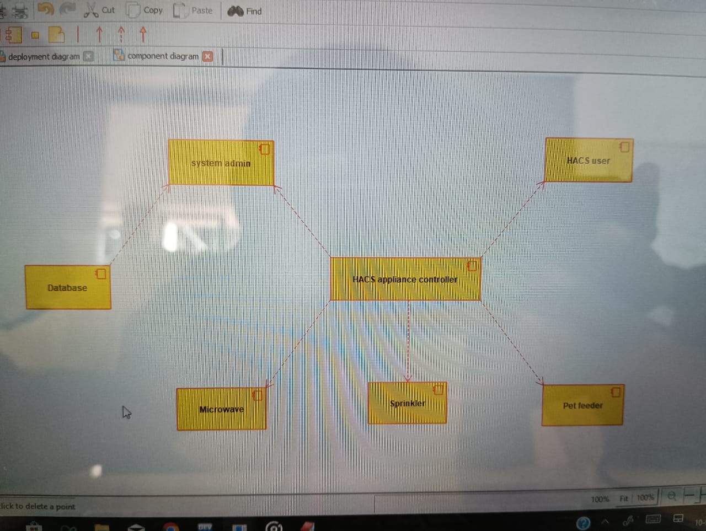

**DEPLOYMENT :**

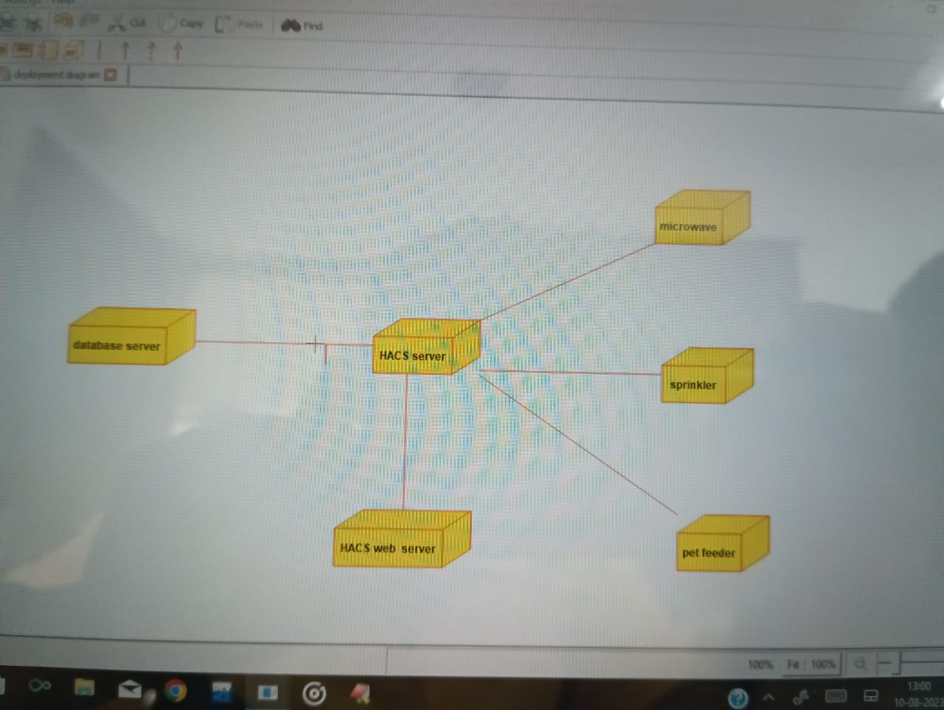

**Use case :**

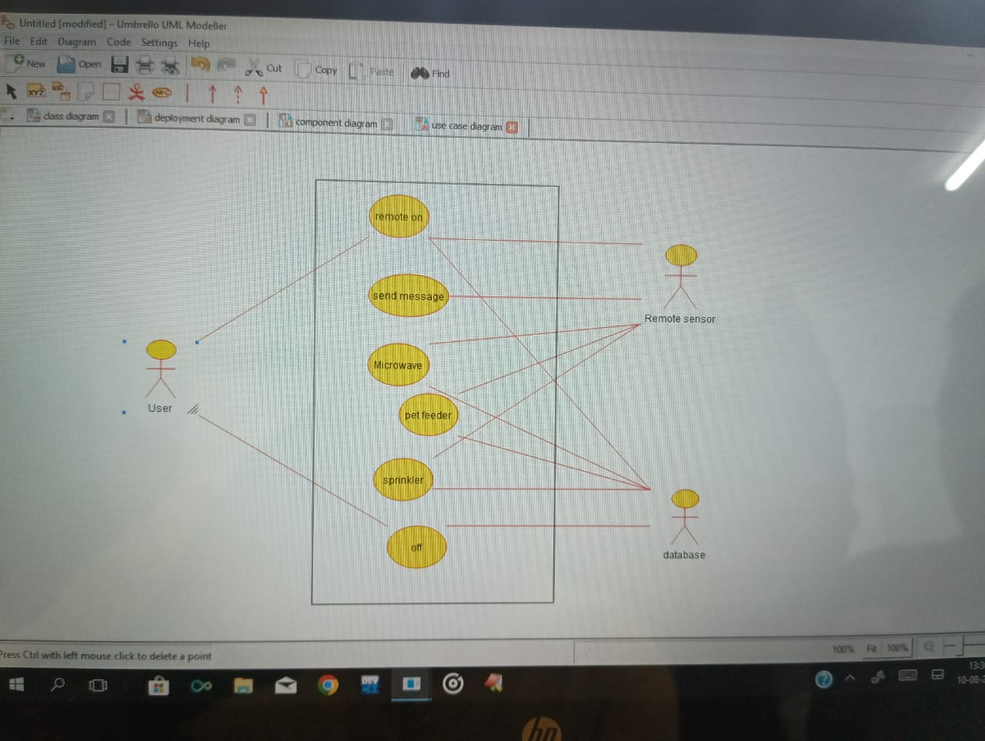

**RESULT** : Program was Executed Successfully using Umbrello**.**

**EXP 20 : LIBRARY MANGMNET SYSTEM**

**AIM :** To draw the UML diagrams for library management system using umbrello.

**CLASS DIAGRAM:**

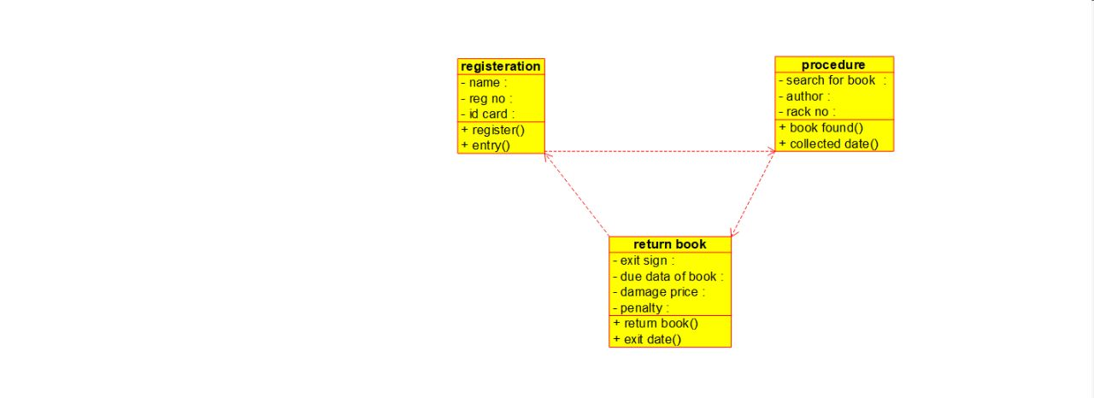

**COLLABRATION :**

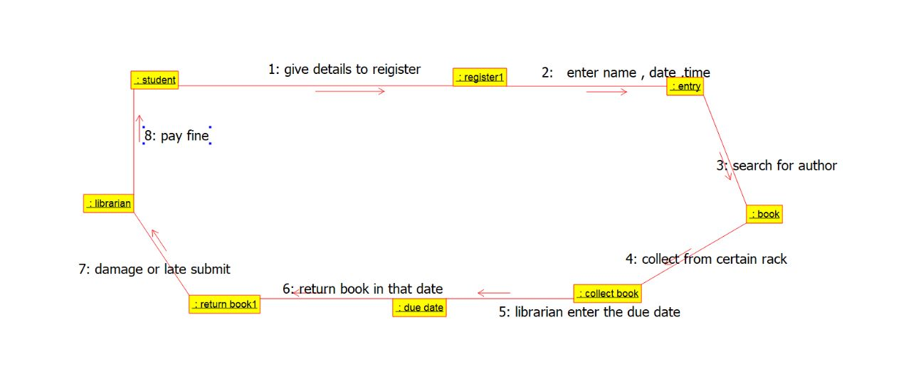

**USE CASE :**

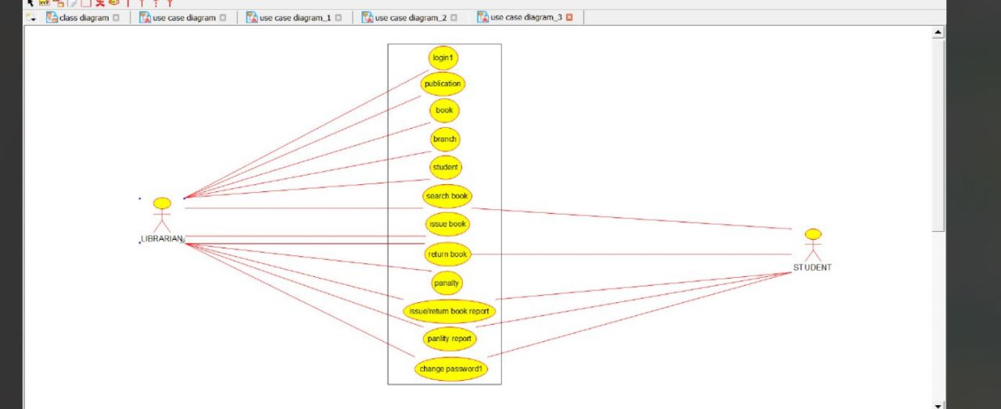

**RESULT** : Program was Executed Successfully using Umbrello**.**

**EXP 21 :** **HOSPITAL MANAGEMENT SYSTEM**

**AIM :** To draw the UML diagrams for hospital management system using umbrello.

**CLASS DIAGRAM:**

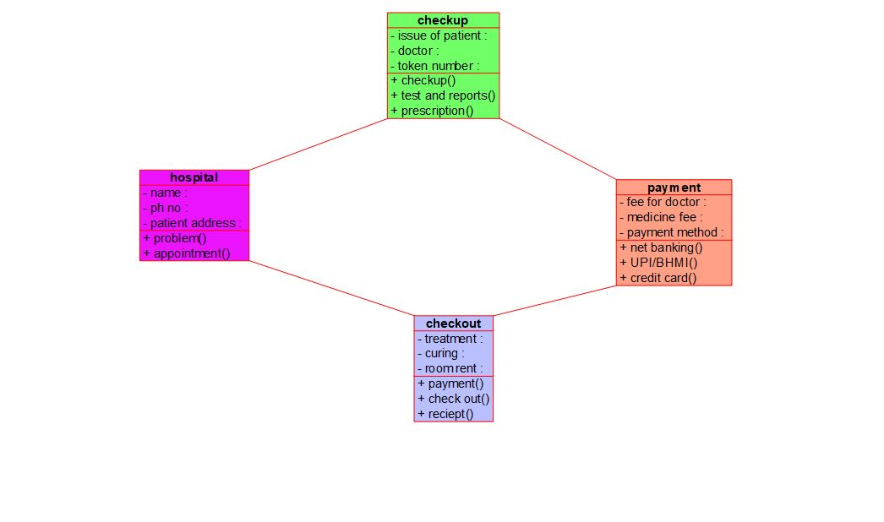

**COMPONENT :**

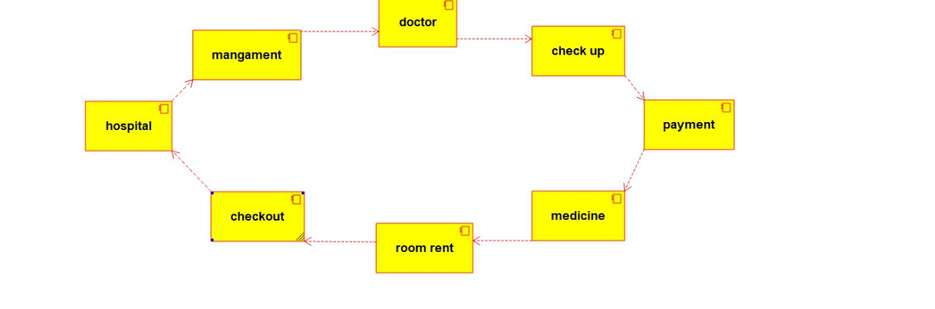

**USE CASE:**

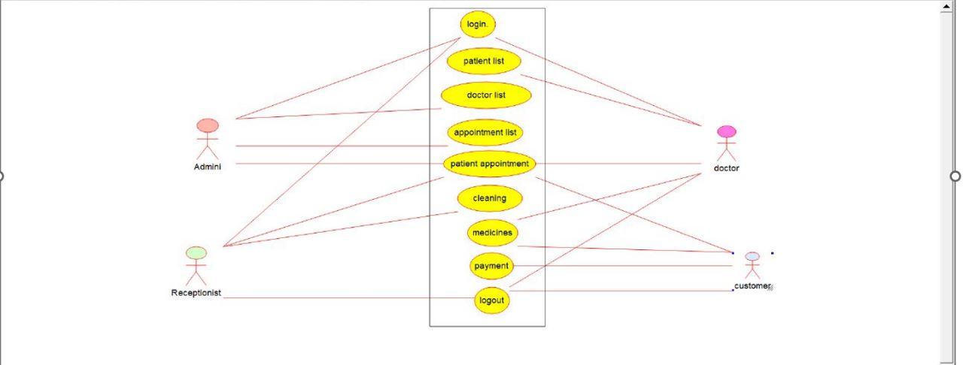

**RESULT** : Program was Executed Successfully using Umbrello**.**

**EXP 22:** **ONLINE INSURANCE SYSTEM**

**AIM :** To draw UML diagram for online insurance system using umbrello.

**ACTIVITY :**

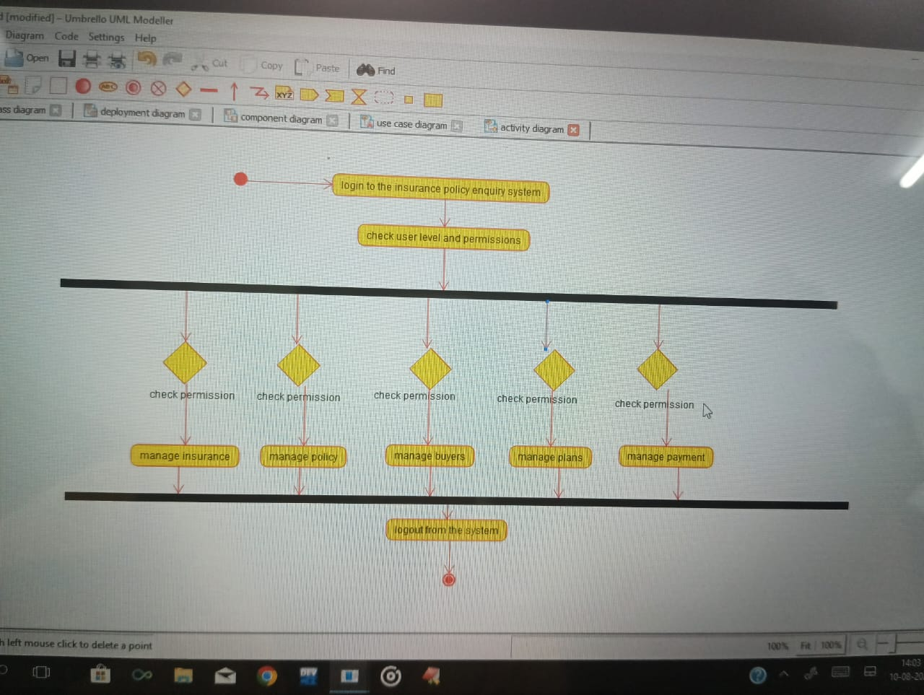

**USE CASE :**

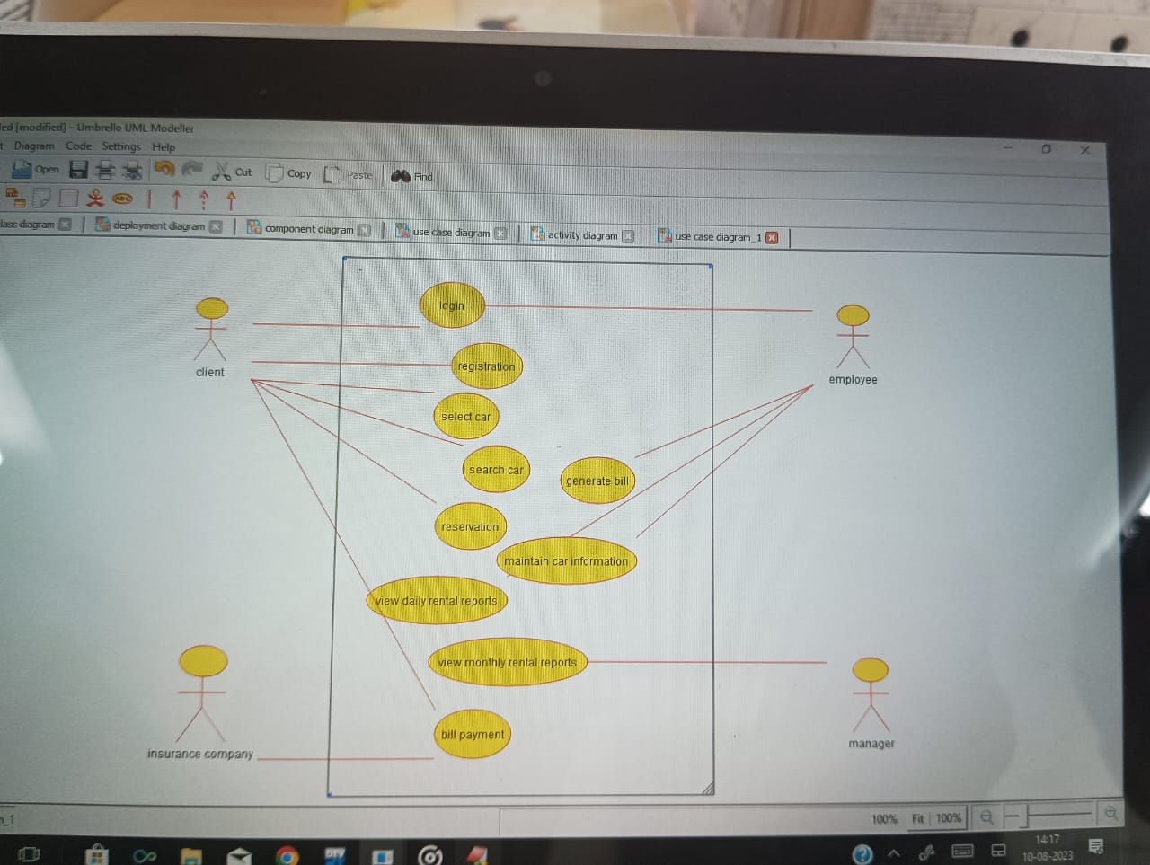

**COMPONENT :**

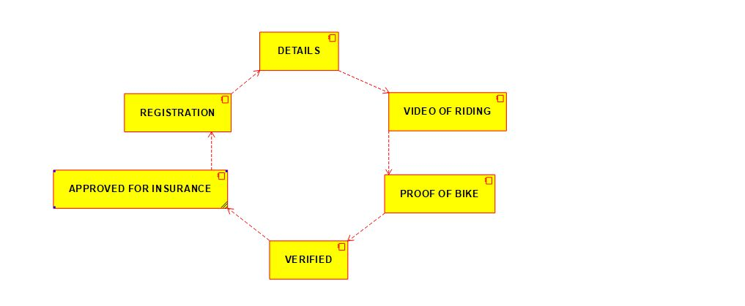

**RESULT** : Program was Executed Successfully using Umbrello**.**

**EXP 23 : ONLINE SHOPPING SYSTEM**

**AIM** : To draw the uml diagram for online shopping system using umbrello.

**Use case :**

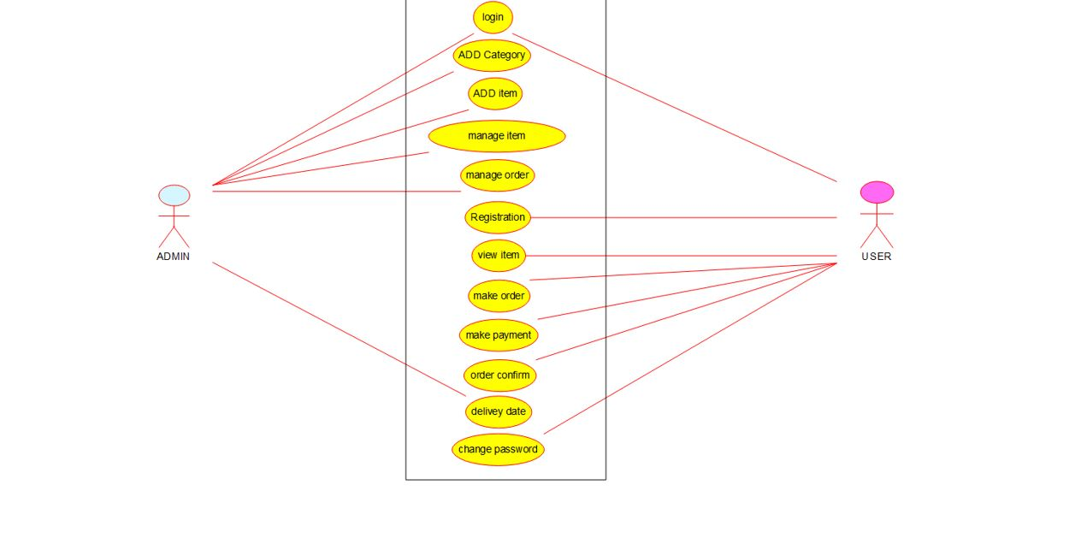

**SEQUENCE :**

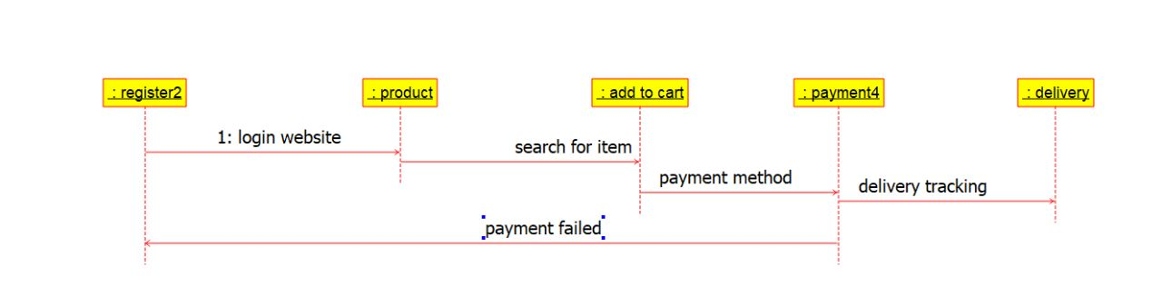

**PACKAGE :**

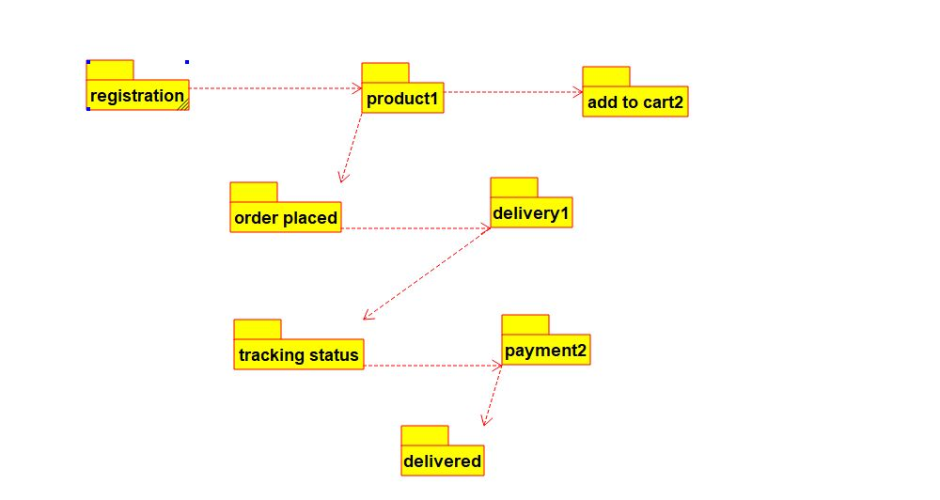

**RESULT** : Program was Executed Successfully using Umbrello**.**

**EXP 24: ONLINE STOCK MARKET**

**AIM :**  To draw the uml diagram for online stock market using umbrello.

**COLLABRATION:**

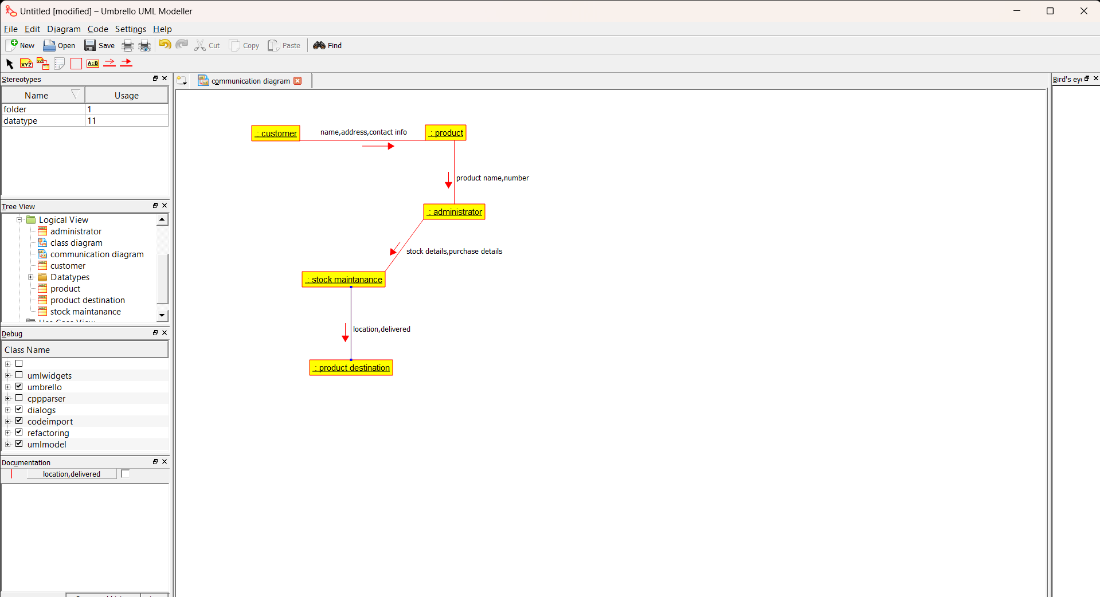

**SEQUENCE:**

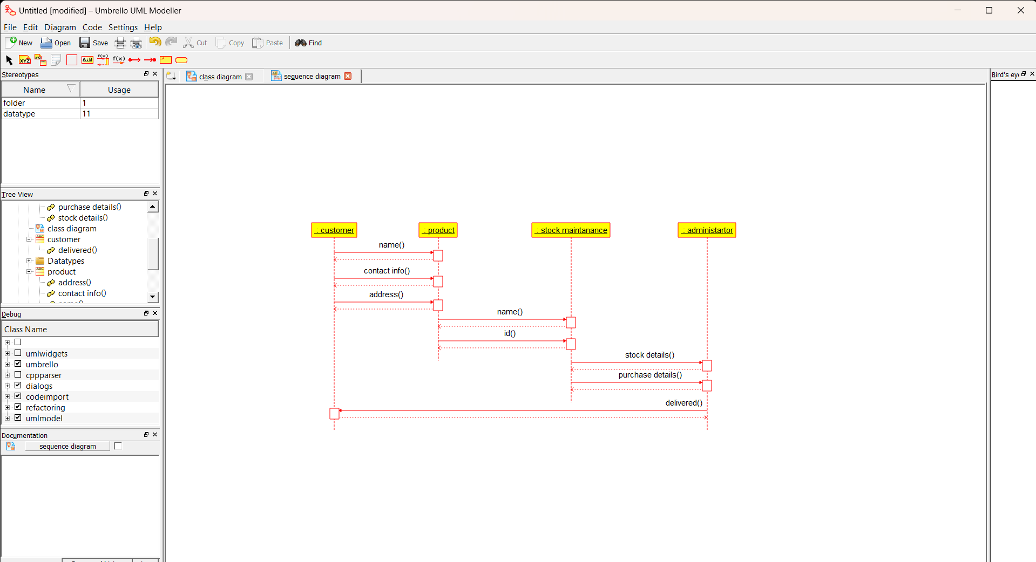

**PACKAGE :**

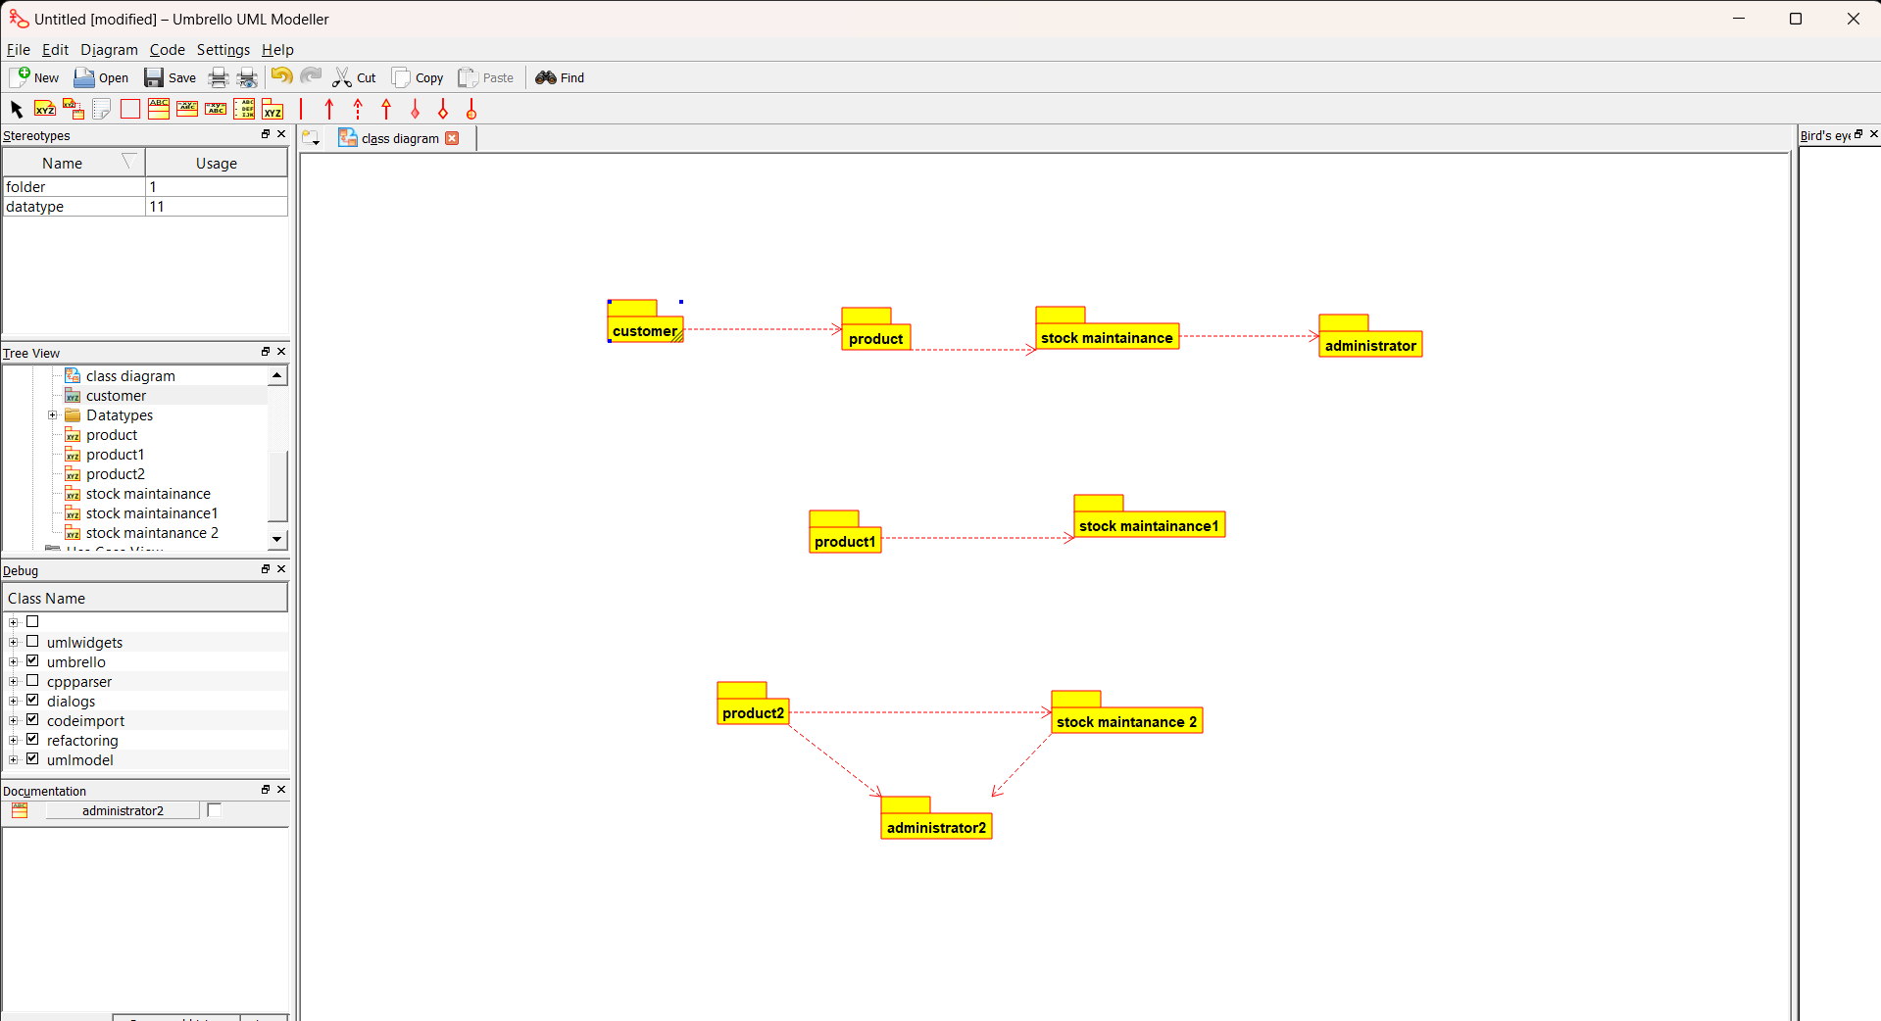

**RESULT** : Program was Executed Successfully using Umbrello**.**

**EXP 25 : ONLINE VOTING SYSTEM**

**AIM : :**  To draw the uml diagram for online voting system using umbrello.

**SEQUENCE :**

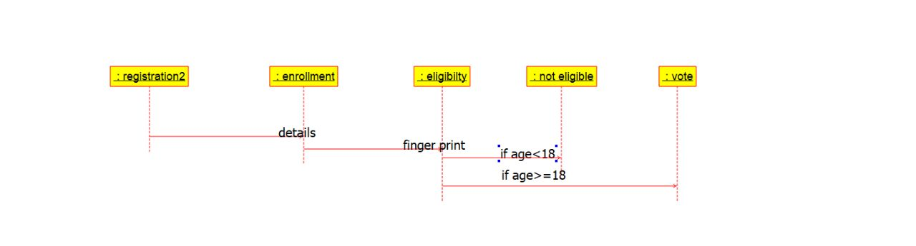

**ACTIVITY :**

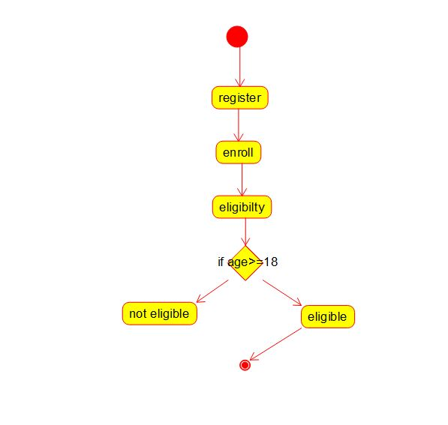

**Component :**

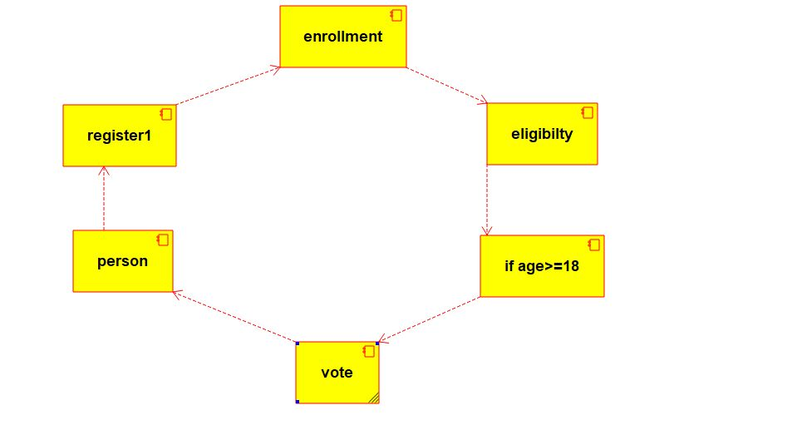

**RESULT** : Program was Executed Successfully using Umbrello**.**

**EXP 26 : JEWELLERY SHOP MANAGMENT**

**AIM :** To draw the UML diagrams for jewellery shop management system using umbrello.

**USE CASE :**

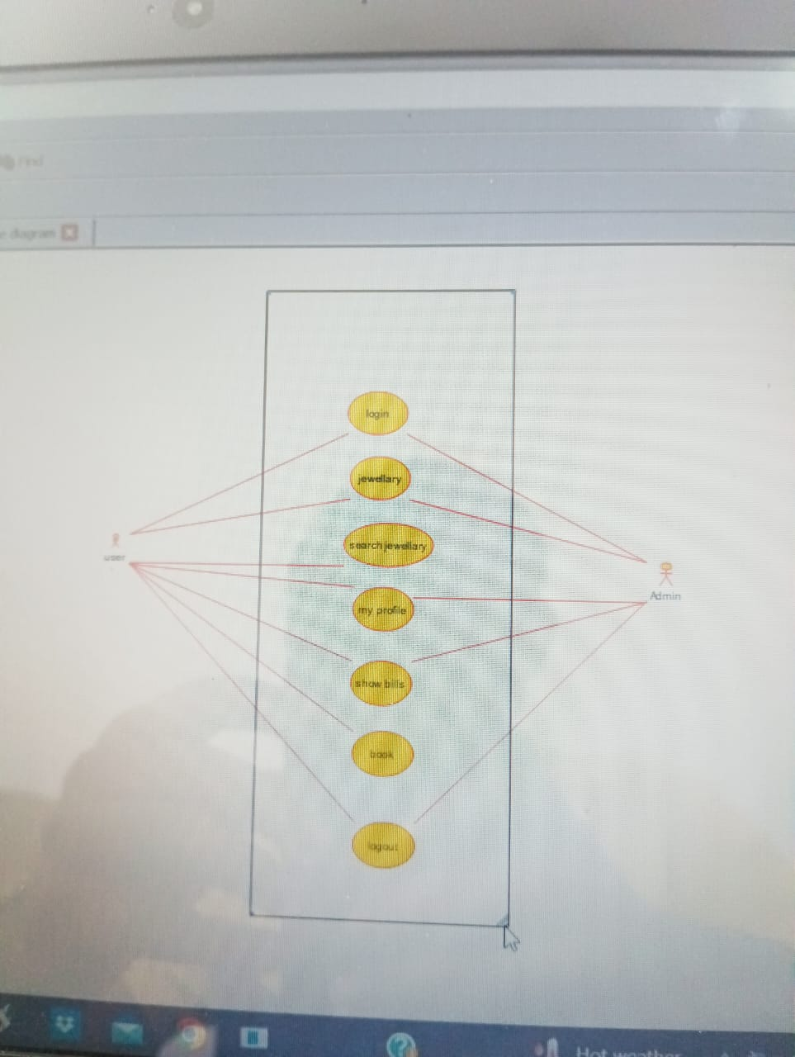

**SEQUENCIAL DIAGRAM:**

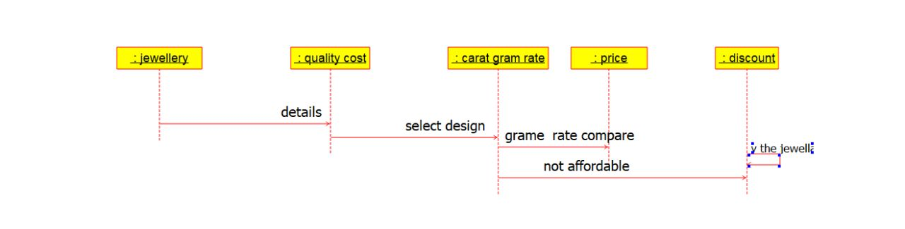

**COMPONENT :**

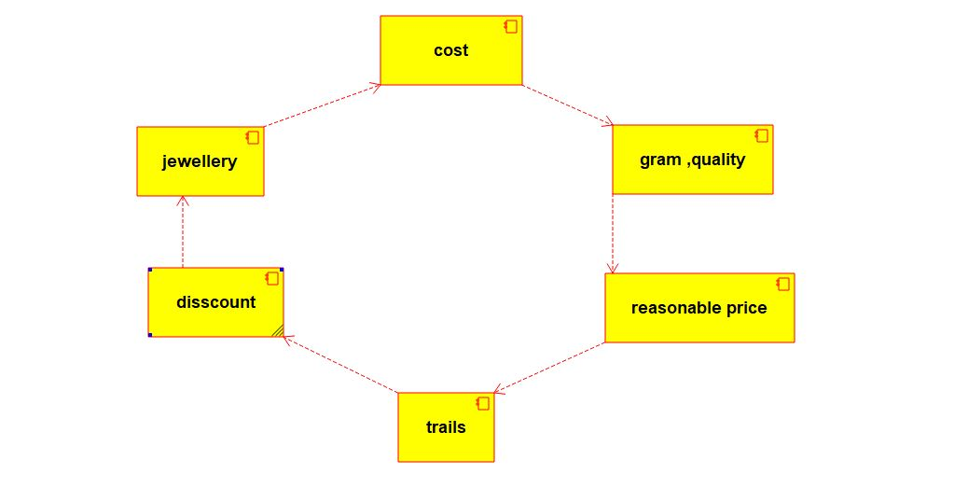

**RESULT :** Program was Executed Successfully using Umbrello.